Name ______________________________________________ Period ______ Date _____________________
Rational Functions Study Guide (Algebra Boot Camp) Honors Calculus Perry
Part I: For each rational function, find all the holes, intercepts, and asymptotes.
Find also the domain, and do a sign analysis. Use each to sketch the graph of the function.
SHOW YOUR WORK ON A SEPARATE SHEET OF PAPER.
1. $f\left(x\right)= \frac{x+3}{-3x+12}$ | 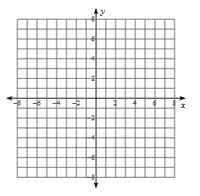
Holes:
Intercepts:
Asymptotes:
Domain:
Sign Analysis:

2. $f\left(x\right)= \frac{x^{2} + x - 12}{x^{2} +5x+4}$

Holes:
Intercepts:
Asymptotes:
Domain:
Sign Analysis:

3. $f\left(x\right)= \frac{-x^{2} + x }{x^{2} + x - 6}$

Holes:
Intercepts:
Asymptotes:
Domain:
Sign Analysis:

4. $f\left(x\right)= \frac{x^{3} - 4x }{{3x}^{2} - 3x}$

Holes:
Intercepts:
Asymptotes:
Domain:
Sign Analysis:

5. $f\left(x\right)= \frac{x+ 2 }{x^{2} + 4}$

Holes:
Intercepts:
Asymptotes:
Domain:
Sign Analysis:

6. $f\left(x\right)= \frac{{4x}^{2} }{x^{2} + 4}$

Holes:
Intercepts:
Asymptotes:
Domain:
Sign Analysis:

Part II: For the graph of each rational function, use what you know about holes, intercepts,
asymptotes, and multiplicity to write a possible equation for the graph. Without using a graphing
calculator, explain how you know that the equation is accurate.
1.  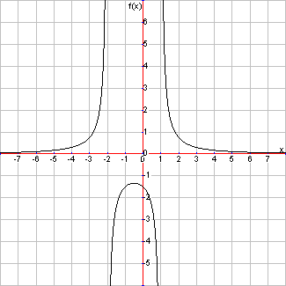 | F(x) =  Explain:

2.  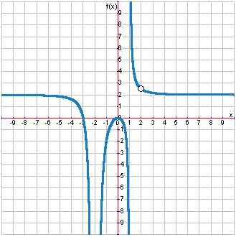 | F(x) =  Explain:

